**MONGODB FILM DATABASE QUERIES**

**DATABASE**

[  
 {  
 "id": 1,  
 "title": "Toy Story",  
 "director": "John Lasseter",  
 "year": 1995,  
 "length_minutes": 81  
 },  
 {  
 "id": 5,  
 "title": "Finding Nemo",  
 "director": "Andrew Stanton",  
 "year": 2003,  
 "length_minutes": 107  
 },  
 {  
 "id": 13,  
 "title": "Brave",  
 "director": "Brenda Chapman",  
 "year": 2012,  
 "length_minutes": 102  
 },  
 {  
 "id": 14,  
 "title": "Monsters University",  
 "director": "Dan Scanlon",  
 "year": 2013,  
 "length_minutes": 110  
 },  
 {  
 "id": 9,  
 "title": "WALL-E",  
 "director": "Andrew Stanton",  
 "year": 2008,  
 "length_minutes": 104  
 },  
 {  
 "id": 10,  
 "title": "Up",  
 "director": "Pete Docter",  
 "year": 2009,  
 "length_minutes": 101  
 },  
 {  
 "id": 12,  
 "title": "Cars 2",  
 "director": "John Lasseter",  
 "year": 2011,  
 "length_minutes": 120  
 },  
 {  
 "id": 6,  
 "title": "The Incredibles",  
 "director": "Brad Bird",  
 "year": 2004,  
 "length_minutes": 116  
 },  
 {  
 "id": 3,  
 "title": "Toy Story 2",  
 "director": "John Lasseter",  
 "year": 1999,  
 "length_minutes": 93  
 },  
 {  
 "id": 4,  
 "title": "Monsters, Inc.",  
 "director": "Pete Docter",  
 "year": 2001,  
 "length_minutes": 92  
 },  
 {  
 "id": 11,  
 "title": "Toy Story 3",  
 "director": "Lee Unkrich",  
 "year": 2010,  
 "length_minutes": 103  
 },  
 {  
 "id": 8,  
 "title": "Ratatouille",  
 "director": "Brad Bird",  
 "year": 2007,  
 "length_minutes": 115  
 },  
 {  
 "id": 2,  
 "title": "A Bug's Life",  
 "director": "John Lasseter",  
 "year": 1998,  
 "length_minutes": 95  
 },  
 {  
 "id": 7,  
 "title": "Cars",  
 "director": "John Lasseter",  
 "year": 2006,  
 "length_minutes": 117  
 }  
 ]

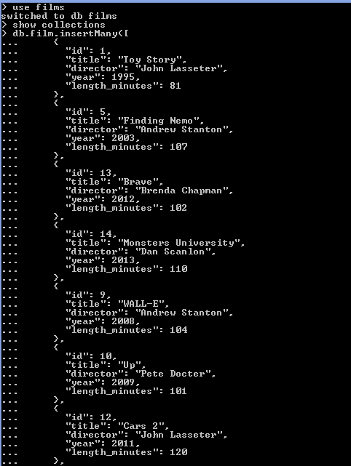

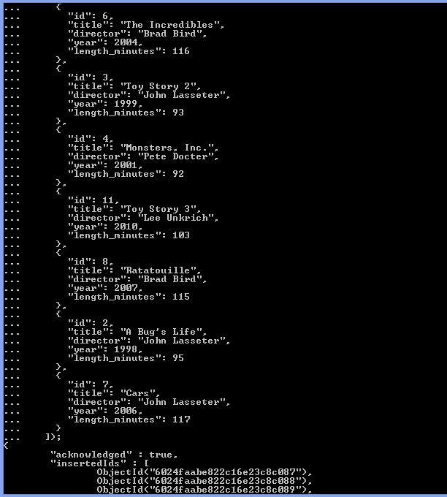

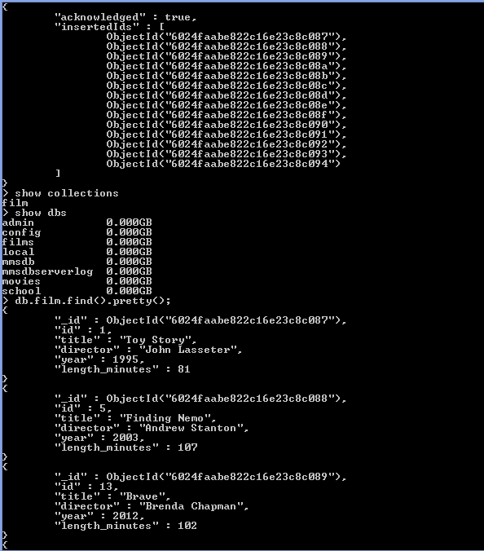

**QUERIES**

1. Find all the information about each film

db.film.find().pretty();

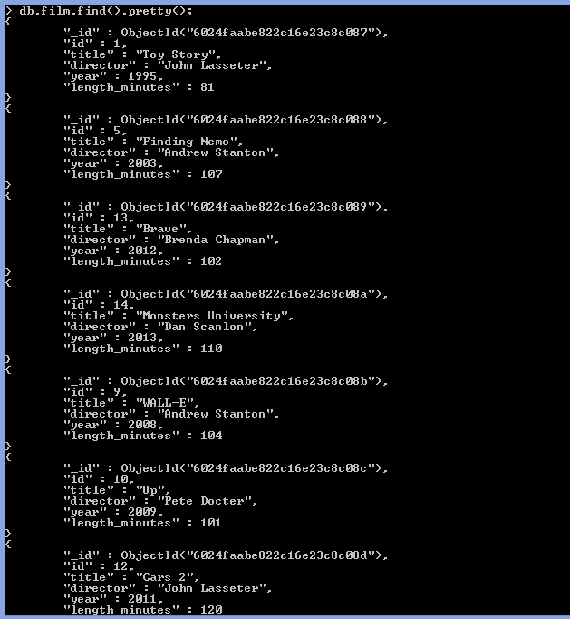

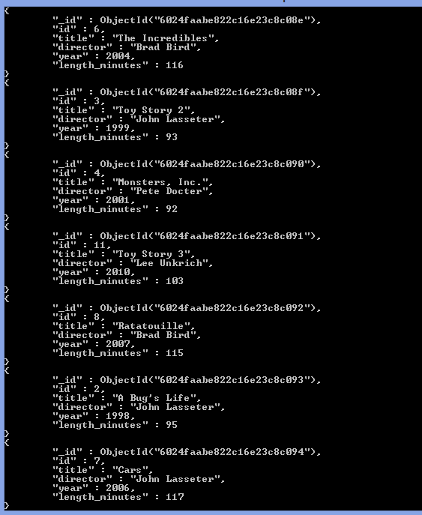

2.Find the title of each film

db.film.find({},{"_id":0,"id":0,"director":0,"year":0,"length_minutes":0}).pretty();

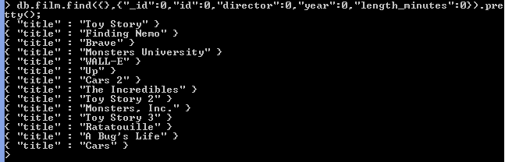  
3.Find the director of each film

db.film.find({},{"_id":0,"id":0,"title":0,"year":0,"length_minutes":0}).pretty();

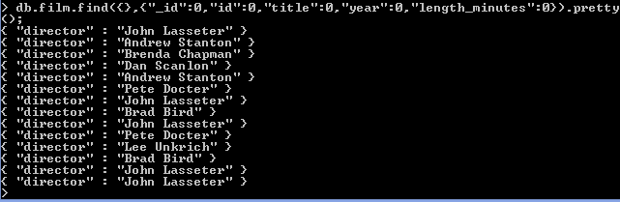  
4.Find the title and director of each film

db.film.find({},{"_id":0,"id":0,"year":0,"length_minutes":0}).pretty();

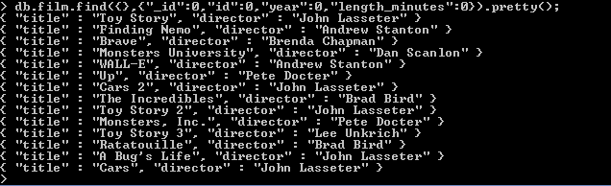  
5. Find the title and year of each film  
db.film.find({},{"_id":0,"id":0,"director":0,"length_minutes":0}).pretty();

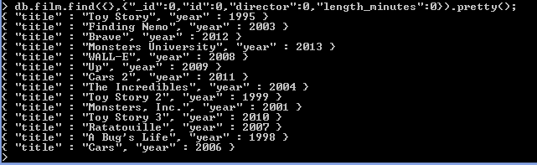6. Find the movie with a row id of 6

db.film.find({"id":6}).pretty();

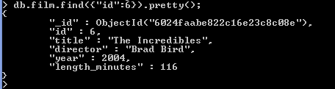  
7.Find the movies released in the years between 2000 and 2010

db.film.find({"year":{$gt:2000,$lt:2010}}).pretty();

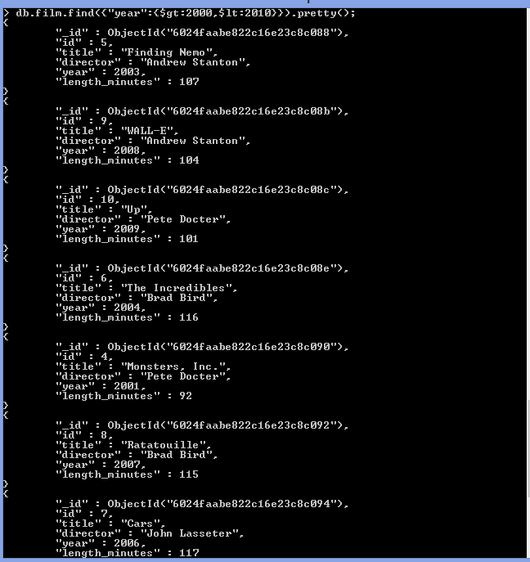  
8. Find the movies not released in the years between 2000 and 2010

db.film.find({"year":{$not:{$gt:2000,$lt:2010}}}).pretty();

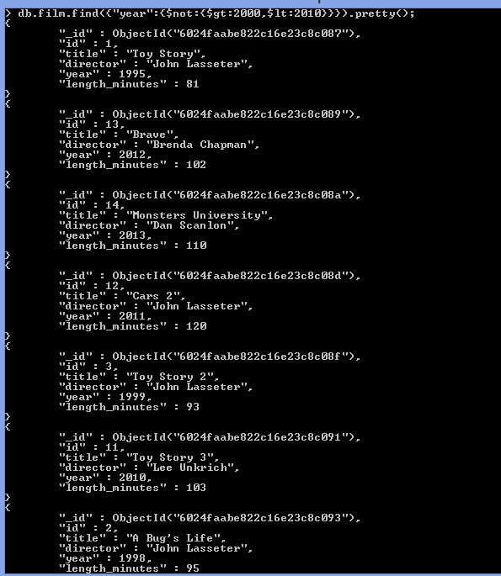

9. Find the first 5 Pixar movies and their release year

db.film.find({},{"_id":0,"id":0,"director":0,"length_minutes":0}).limit(5).pretty();

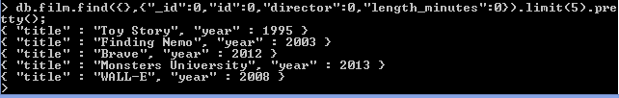  
  
10. Find all the Toy Story movies

db.film.find({"title":{$regex:"Toy Story"}}).pretty();

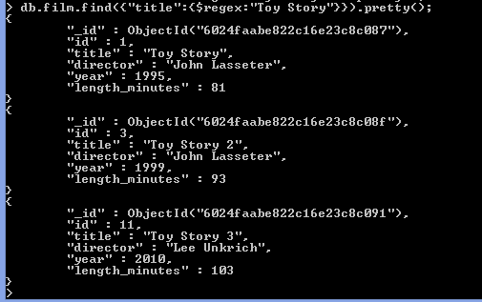  
11.Find all the movies directed by John Lasseter

db.film.find({"director":{$regex:"John Lasseter"}}).pretty();

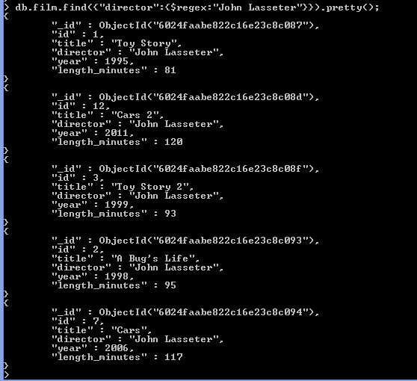  
12.Find all the movies (and director) not directed by John Lasseter  
Find all the WALL-* movies  
db.film.find({"title":{$regex:"WALL-*"}}).pretty();

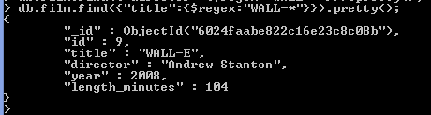  
13. List the last four Pixar movies released (ordered from most recent to least)

db.film.find().sort({"year":-1}).limit(4).pretty();

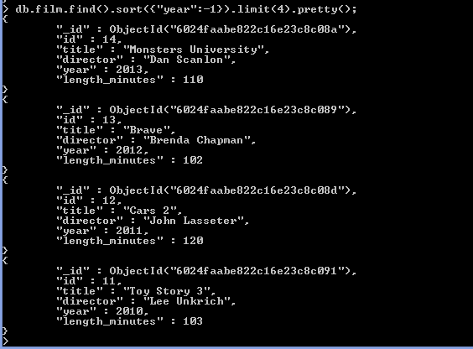  
14.List the first five Pixar movies sorted alphabetically

db.film.find().sort({"title":1}).limit(5).pretty();

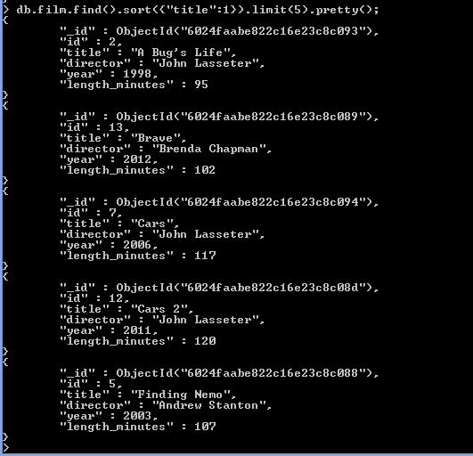  
15.List the next five Pixar movies sorted alphabetically

db.film.find().sort({"title":1}).limit(4).skip(5).pretty();

